CIRRICULAM VITA

PERSONAL DETAILS: JANGITI MAMATHA
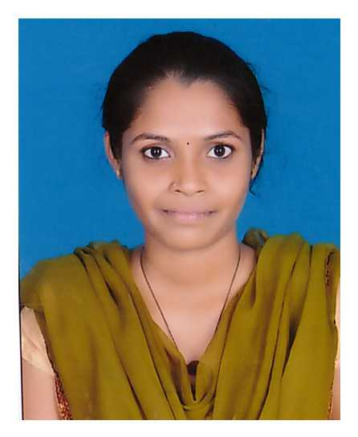

Residential Address: H.No:3-5-24/R84 Rajeev Nagar,
Moula-Ali,
Hyderabad500-040
Mobile : 7032284640
Date of Birth : 25 Nov 1992
Nationality : INDIAN
Mail Id : mammuhomey65@gmail.com

CAREER OBJECTIVE

I completed B.Tech in computer science of Engineering. To get an entry level position and acquire a bright career in a good organization in the field of computer & Technology I am looking forward for a position that will enhance my skills and provides me an environment to use my knowledge gained through education for the growth of the company.

EDUCATION HISTORY

May 2014 – Current : Tirumala Engineering College (J.N.T.U.H)
I have completed B.Tech in the year 2010-2014 with 61%
In the Departnment of Computer Science of Engineering

Jun 2008 – May 2010 : Board of Intermediate Education
I have completed Intermediate in Narayana Junior College
Pass out in the Year of 2008-2010 with51% in the branch of
M.P.C

June 199 – March 2008: Board of Secondary Education
I would has been completed my primary and secondary
Education in Mother Theresa High School Certificate equivalent
With 66%

WORK EXPERIENCE : AEGIS
I was having the work experience of 18months as an executive in the AEGIS (B.P.O) Corporate Company.

PROJECT EXPERIENCE:

I have been done my Mini Project in NEO App Technologies Pvt. Ltd. I have successfully
Completed project work

TITLE NAME: “Attacking on Low-latency Anonymous Communication System (TOR) using Cell Counting based Attack” as part of my academic Project.

I have done project using .NET during the period of 2nd June 2013 to 30th June 2013

I have been done my Major Project in 360 Digit I have successfully completed Project work

TITLE NAME: “Enabling For Cost-Effective Privacy Preserving of Intermediate
Data Sets in Clouds” as part of my academic project.

I have done Project using during the period of 15th Sep 2013 to 15th April 2014

DESCRIPTION:

Cloud-based out sourced storage relieves the client’s burden for storage Management and maintenance by providing a Comparable Low-cost Scalable, Location-Independent Platform.

OTHER SKILLS AND CERTIFICATES

Computer Skills:

Operating system, windows, MS Office, (Word, Excel, PowerPoint) Internet, C-Language, Java scripts, .Net, Web Technology PageMaker, CorelDraw, Photoshop, D.T.P.
I am having the Computer basic certificates from Mother Theresa high school

Language Skills:

Telugu (Is my mother tongue)
Hindi, English (Both the languages I can read and write)

PERSONAL COMPETENCIES

Ability to work in a fast-peaced environment to set deadlines
Excellent oral and written correspondence with an exceptional attention to detail
Highly organized with a creative flair for project work
Enthusiastic self-starter who contributes well to the team

INTERESTS:
- Reading books.
- Reading news papers.
- Learn new things.
- Hard working.

DECLARATION:
I hereby declare that all the information finished above is true to the best of my Knowledge

Date:
Place: Hyderabad. J.MAMATHA

